Installing Uniface on Windows NT 4.0 Cluster

Scope
This document describes installing Uniface on a Windows NT Cluster environment. It does not describe how to install and configure the cluster itself. It is assumed that the reader has Windows NT and cluster environment knowledge and that the NT cluster is configured and operational. It is as well assumed that the reader has already previous experience of installing the Uniface products.

Environment – hardware used
Two identical DELL machines, each having one system disk and one network adapter.
Two external disks, not mirrored and on additional SCSI controllers, defined as cluster resources.

Note: In house hardware was used. In a real life cluster environment it is assumed that at least two network adapters per machine are used.

Environment – software used
OS: Windows NT 4.0 Enterprise Edition + cluster software
Uniface 7.2.06
Data Source: DB3

Note: DB3 was used for simplicity purposes. Installing/configuring/using other data source is beyond the scope of this document.

ServerA: CWNL-C1661
ServerB: CWNL-C1652
Cluster : CWNL-FCS-CL1

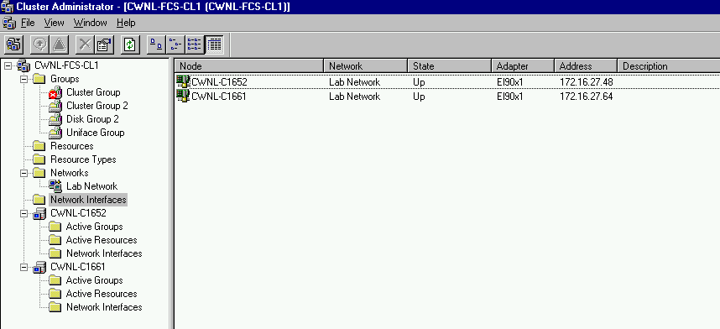
Picture 1: Screenshot from the Cluster Administrator

Note: There are two scenarios tested. They might or might not reflect exactly some real world configurations, but will give enough guidance to make any configuration done.
Scenario 1:
Uniface run time environment is installed on the clients. Uniface Polyserver (PSV) and Uniface Application Server (ASV) are installed on the cluster.

Note: ServerA (cwnl-c1661) is serving the sources of the cluster.
- Using the Cluster Administrator, create Uniface Group.
- Add in the Uniface Group new resource Physical Disk – “Disk E:”(in the current configuration)

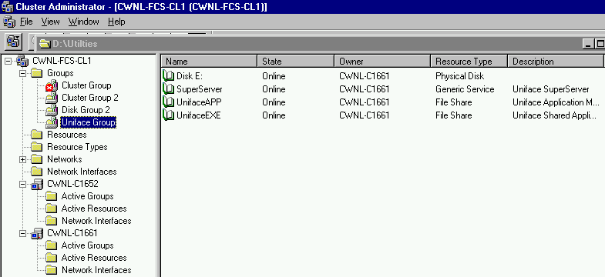
Picture 2 – Uniface Group

- Install PSV and ASV on “Disk E:” (Directory E:\USYS7206 was used)

- Configure and test PSV and ASV using the ServerA which is the current owner of the resource “Disk E:”. (CWNL-C1661). The assignment settings for the TCP path on the client should be defined to:
$PSV TCP:cwnl-c1661+port|username|password|PSV
$ASV TCP:cwnl-c1661+port|username|password|ASV

- After the tests have been successful, using the Cluster Administrator, select the Uniface Group and add a new resource “Generic Service” – “SuperServer” (in the current configuration)

- The Generic Service has the following properties:

General
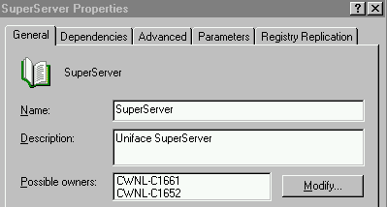
Picture 3

Dependencies

It’s very important that the dependence of the Generic Service “SuperServer” from the Physical Disk “Disk E:” is established. If the Uniface Group has to change the Owner (in current configuration to move from CWNL-C1661 to CWNL-C1652) then before the “SuperServer” is started “Disk E:” must be available.

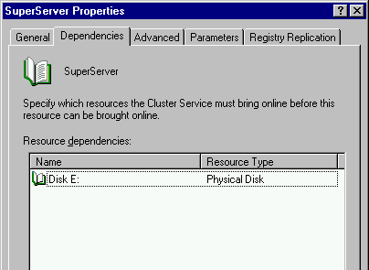
Picture 4

Parameters

Service name must be defined as it is displayed when you activate Services in the Control Panel. In the current configuration this is “TCP SuperServer”

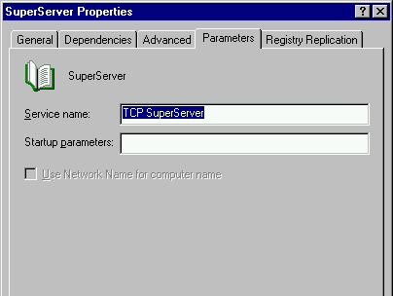
Picture 5

Registry Replication

The registry key from the current owner, ServerA (CWNL-C1661) that defines the “TCP SuperServer” must be replicated to the other node, ServerB (CWNL-C1652), so it must be added to the list of Registry Replication.

NOTE: The name displayed for a service when you open Services window in Control Panel does not have to be the same as the Registry Key. Each Key has a DisplayName property that defines the name displayed when you open Services window. (Run the Registry Editor and position yourself on the any Key that defines a service. On the right pane there is a property defined called DisplayName.)

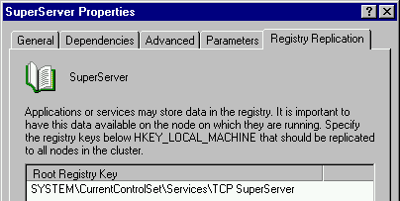
Picture 6

After the Generic Service was added, you can check with the Registry Editor if the Key was successfully replicated at ServerB (CWNL-C1652). It will be noticed that although the key was successfully replicated, it will not be displayed in the Services window. It will be displayed after ServerB is rebooted.

- Update file services on ServerB (CWNL-C1652) with

polyserver 12000/tcp #Uniface Polyserver

- Reboot ServerB

- When UNIFACE PSV & ASV are installed on the ServerA (CWNL-C1661), a local user group “Uniface Server Users” is created. The same group must be created manually on the ServerB (CWNL-C1652) and assigned “Log on as a batch job” right. (User Manager).

Suggestion: To make maintaining of the list of the Uniface users easier (maintaining one list instead of two), it’s advisable to create a Uniface user group (Global Group) at the NT domain level. This user group should then be added to the local “Uniface Server Users” group on both servers.

- Redefine the TCP path to point to the cluster.
$PSV TCP:cwnl-fcs-cl1+port|username|password|PSV
$ASV TCP:cwnl-fcs-cl1+port|username|password|ASV

Test the connection. (Owner is ServerA)
In the Cluster Administrator right click the Uniface Group and Move the group. This will change the Owner of the group from ServerA (CWNL-C1661) to ServerB (CWNL-C1652). You will notice that the Uniface Group will be brought Offline and then brought Online with the new Owner (CWNL-C1652)
Test the connection. (Owner is ServerB)

Scenario 2
Clients run Uniface application installed on the cluster.

- Using the Cluster Administrator, create Uniface Group.

- Add in the Uniface Group new resource Physical Disk – “Disk E:” in the current configuration

- Add in the Uniface Group new resource File Share – “UnifaceEXE” in the current configuration. This resource should point to the installation directory of Uniface. The dependency of “Disk E:” must be established.

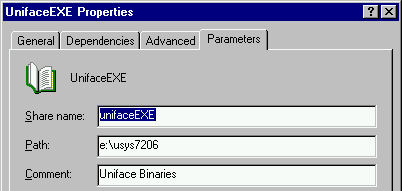
Picture 7

- Add in the Uniface Group new resource File Share – “UnifaceAPP” in the current configuration. This resource should point to directory where the application components are placed. The dependency of “Disk E:” must be established.

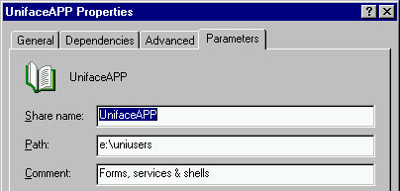
Picture 8

- Test the application

Some other notes
Uniface Web Application Server was not tested. It falls basically in Scenario 1. First IIS must be configured in a cluster environment.

Case studies about NT clustering can be found on the Microsoft site at:
http://www.microsoft.com/ntserver/ntserverenterprise/solutions/default.asp

Tested & Written by
Ratko Popovski & Nico Peereboom

